Data Cleaning & Processing

A comprehensive data cleaning and transformation process was performed using Power Query to ensure the dataset was accurate, consistent, and suitable for analytical modeling. Since the data was sourced from multiple files, several preprocessing steps were required to standardize and enrich the dataset.
Data modelling
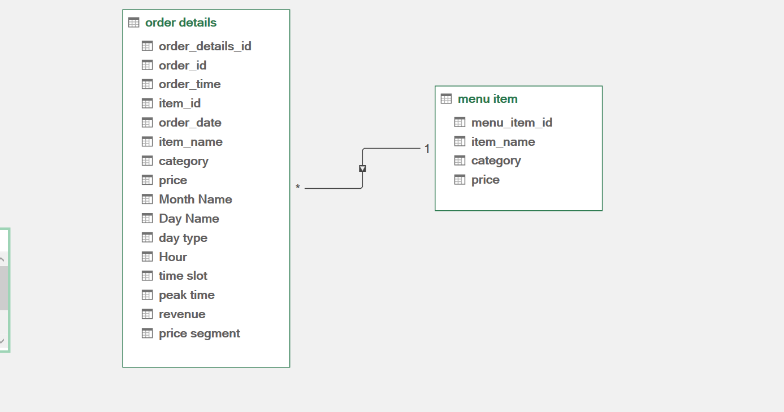
- Data Import and Integration

The dataset was collected from two different sources:
- Order Details (CSV file)
- Menu Items (Excel file)
Both datasets were imported into Power Query and prepared individually before integration. The Menu Items dataset was cleaned by promoting headers, correcting data types, and filtering out null category values.

2. Data Type Standardization

To ensure consistency and prevent calculation errors:
- Order ID, Item ID, and Order Details ID were converted to numeric format.
- Order Time was converted into time format.
- Price was set as a decimal number.
- Order Date was initially treated as text to handle format inconsistencies before conversion.
3. Handling Date Format Inconsistencies
The Order Date column contained mixed date formats (e.g., MM/DD/YY and DD/MM/YY), which caused parsing errors in Power Query. To address this:
- A conditional transformation approach was applied using multiple locale formats (US and UK).
- Dates were first attempted to be parsed using US format; if unsuccessful, UK format was applied.
- Only valid parsed dates were retained to ensure accuracy in time-based analysis.
This step was critical to maintaining data integrity and enabling accurate temporal analysis such as monthly and daily trends.

4. Error Handling and Data Filtering

- Invalid or unparseable date values were identified and removed.
- Rows with null or missing critical values (such as revenue-related fields) were filtered out.
- This ensured that downstream calculations and aggregations were not affected by incomplete or erroneous data.

5. Duplicate Handling

Duplicate records based on Order ID and Order Date were identified and removed. This step was important to:
- Avoid double counting of orders
- Ensure accurate calculation of order-level metrics such as total orders and average items per order

6. Data Integration (Merging Tables)

The cleaned Order Details dataset was merged with the Menu Items dataset using:
- Order Details: Item ID
- Menu Items: Menu Item ID
This join enriched the transactional dataset with product-level information such as:
- Item Name
- Category
- Price

7. Feature Engineering (Derived Columns)

Several new columns were created to enhance analytical capabilities:
- Month Name: Extracted from Order Date for monthly trend analysis
- Day Name: Used to identify daily patterns
- Day Type: Categorized into Weekday and Weekend for behavioral insights
- Hour: Extracted from Order Time to analyze hourly trends
- Time Slot: Categorized into Morning, Afternoon, and Evening
- Peak Time: Defined to identify high-demand periods during the day
- Revenue: Derived directly from item price, assuming each row represents one unit sold
- Price Segment: Categorized items into Cheap, Medium, and High based on price range
These engineered features enabled deeper insights into customer behavior, time-based demand, and product performance.

8. Data Validation and Final Preparation

- All columns were reviewed for correct data types and consistency.
- Column names were standardized for clarity and usability.
- The final dataset was verified to ensure there were no remaining null values or transformation errors.
The cleaned and transformed dataset was then loaded into the Data Model for further analysis using Power Pivot.

Overall, the data processing phase ensured high data quality, improved consistency across fields, and enabled accurate and meaningful analysis for business insights and dashboard creation.

